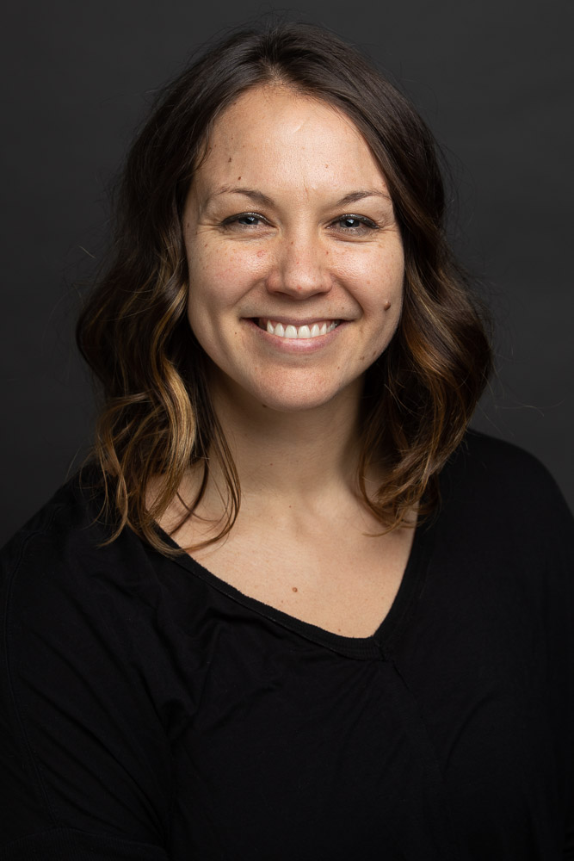
Dr. Lindsey Hughey graduated from University of the Sciences in Philadelphia with her bachelor in health science and doctorate in physical therapy (DPT). Since graduation, Dr. Hughey has worked with orthopedic populations in both the outpatient and inpatient settings. Dr. Hughey is a board certified orthopedic clinical specialist (OCS) and Fellow of the American Academy of Orthopaedic Manual Physical Therapists (FAAOMPT). She serves as part-time core faculty at South College DPT. She has a passion for clinical excellence and evidenced based practice, and loves to share this passion through teaching and mentoring. She is a member of the APTA and the American Academy of Orthopaedic Manual Physical Therapists (AAOMPT). Dr. Hughey currently practices part-time in her out of network private practice, called drive PT and serves as a faculty member of the Institute of Clinical Excellence-extremity management division. Dr. Hughey has a special interest in working with CrossFit athletes and people living with chronic pain. Outside of physical therapy, she enjoys time spent with her husband, Adam and three children Daniel, Jacklyn, and Luke.

